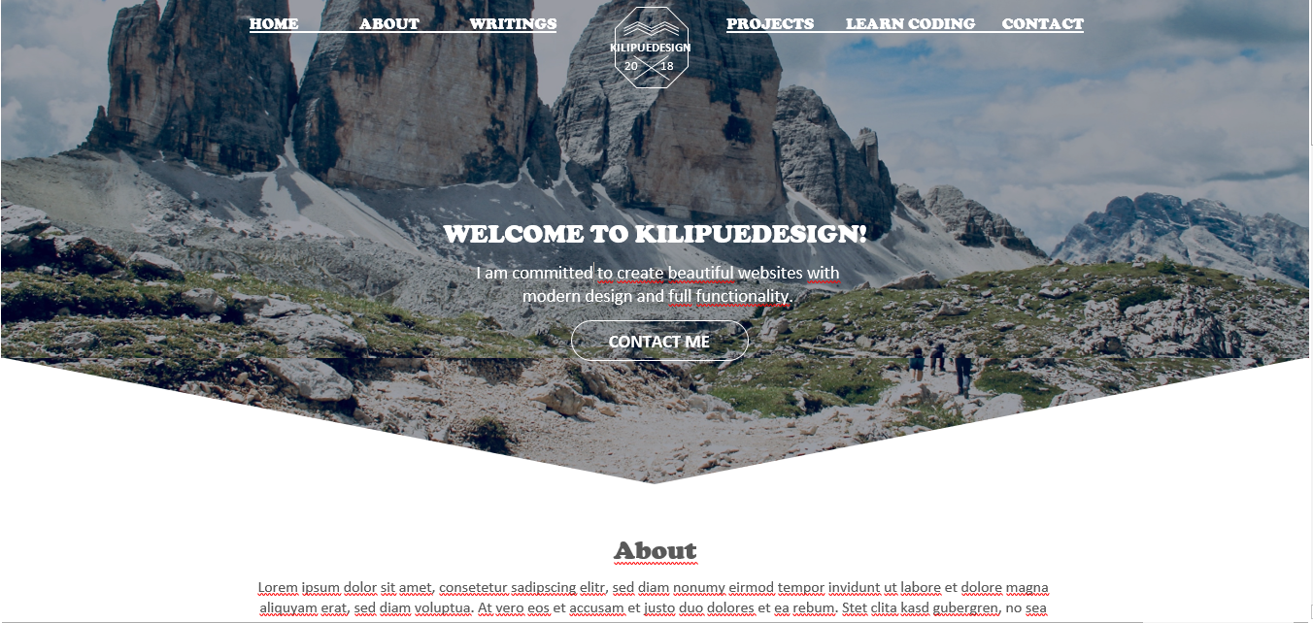

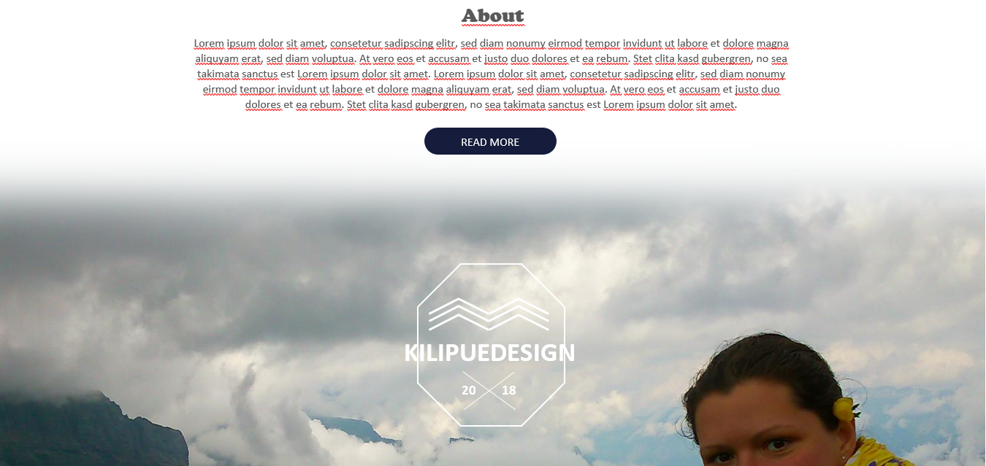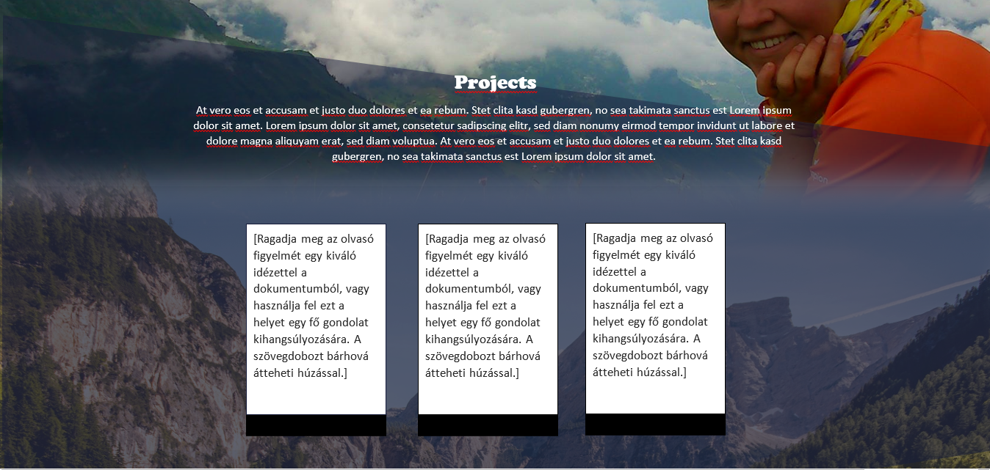

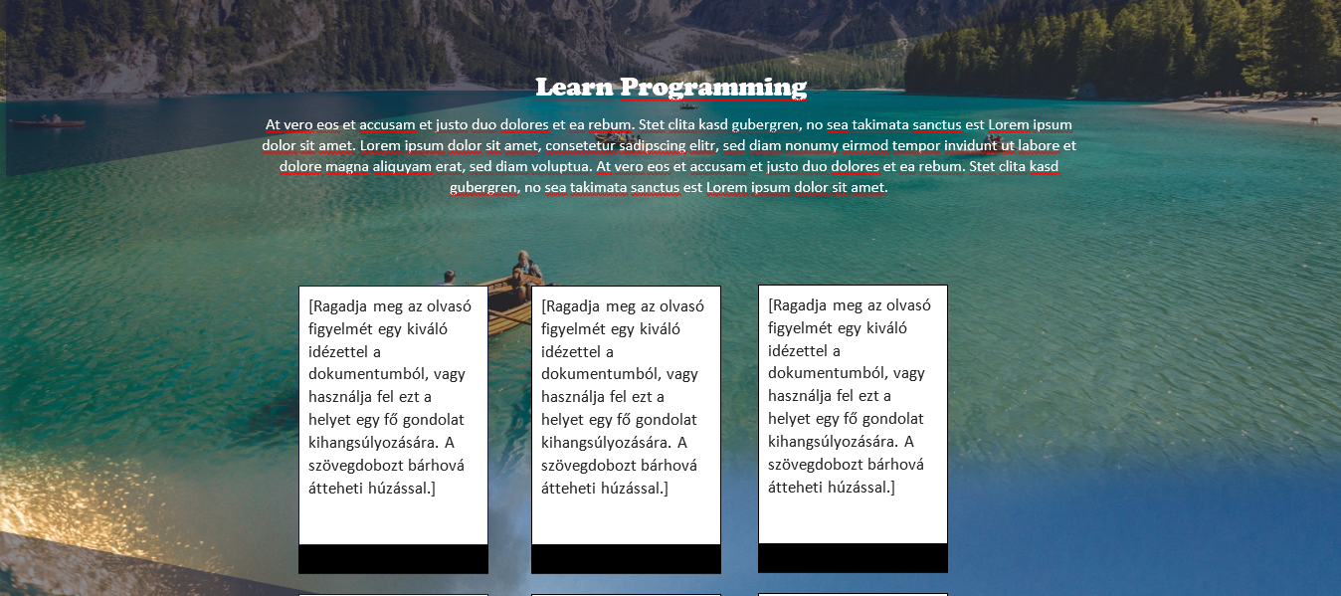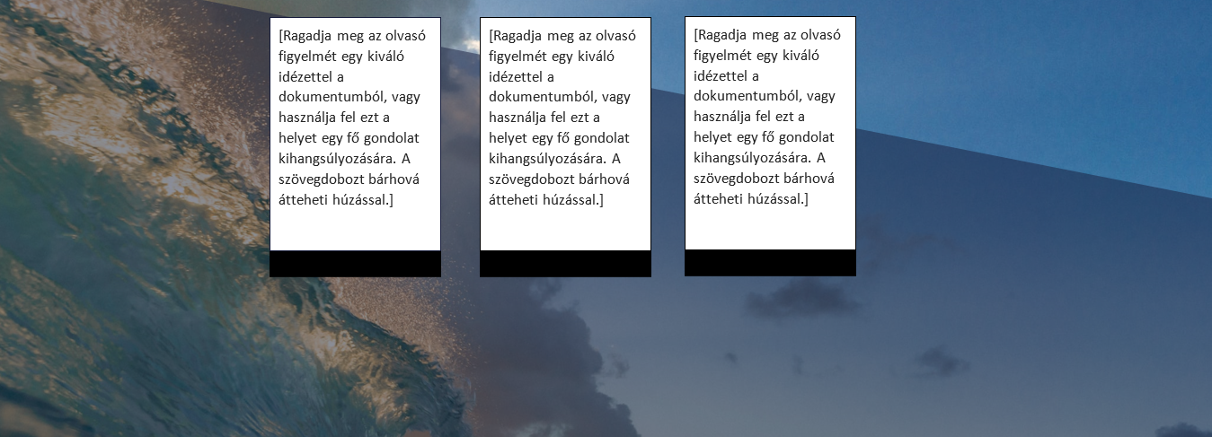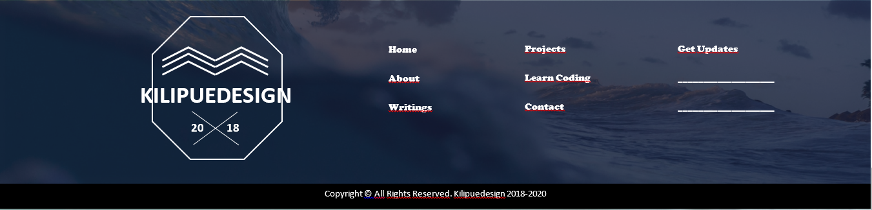

# Navigation



# Icons

         

 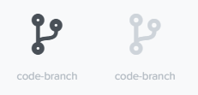 

# Buttons

  

# Typography and Fonts

Cooper Black

Aa Bb Cc Dd Ee Ff Gg Hh Ii Jj Kk Ll Mm Nn Oo Pp Qq Rr Ss Tt Uu Vv Ww Xx Yy Zz

1 2 3 4 5 6 7 8 9 0 ? ! . - + - # & @ %

Arial

Aa Bb Cc Dd Ee Ff Gg Hh Ii Jj Kk Ll Mm Nn Oo Pp Qq Rr Ss Tt Uu Vv Ww Xx Yy Zz

1 2 3 4 5 6 7 8 9 0 ? ! . - + - # & @ %

Headers

Welcome to kilipuedesign! h1 – 1.6rem

About h2 – 1.6rem

Text

I have started programming with zero knowledge in programming languages. Today in the world of web 2.0 built on community contribution and lots of online resources it is easy to get knowledge about a lot of things. Why not learn programming? – 1rem

# Colors

## Background

 Accent BG

#8aa6bf

Accent BG 2

#a3a5a9

Primary BG

#fff

#

## Text

Primary text

#fff

 Secondary text

#283540

Disabled text

#808492

Accent text

#1a1a1a

## Button

 Primary button

#283540

Accent button

#a3a5a9

## Borders

Primary border

#fff

